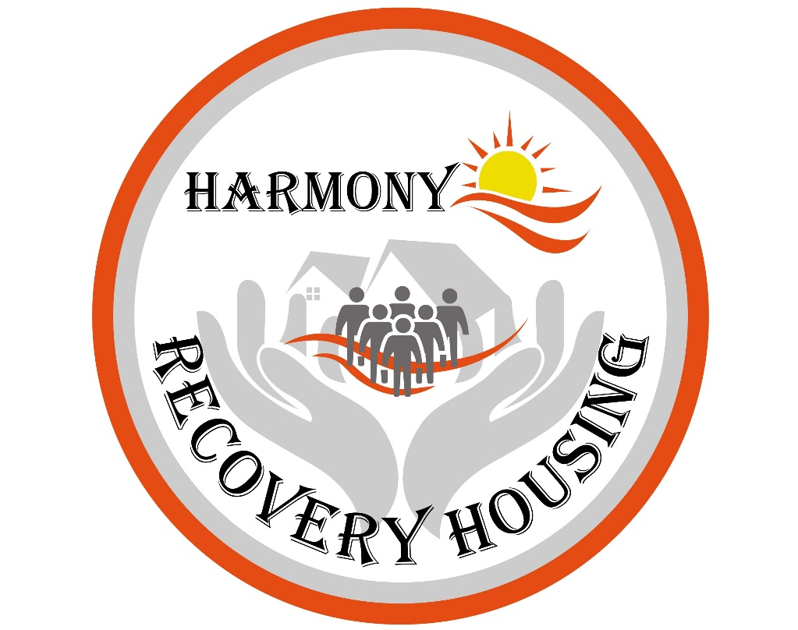

HOUSE RULES

*LANDLORD - TENANT RULES DO NOT APPLY TO TEMPORARY HOUSING*

Our Mission:

Our foundation is built upon our passion to provide a safe, comfortable housing option to populations at-risk. We strive to inspire a meaningful, vibrant life during transitional housing and enrich the lives of our residents with respect, integrity, and kindness. It’s not just a place where you reside, but an environment filled with compassion, encouragement, laughter, and joy that really feels like home.

Reese Edwards / Jeff Edwards - (904) 274 - 0922

Welcome to HARMONY RECOVERY HOUSING. These rules are in place because they are consistent with community placement practices. Please review carefully, as all residents will be expected to comply. This may not be a comprehensive list and management reserves the right to add or edit ANY rules. If not in writing, then changes will be discussed during house meetings.

HOUSING ROOM CHARGES - FINANCIAL DISCLOSURE

- Room charges must be paid each Friday. Fees are considered late if not received by 5:00pm on Mondays. If you are late on your room fee, you will be charged a late fee of $20. If not paid up to date after two weeks, your Residency contract may be terminated.

- You are responsible for making sure that your room fee is paid on time, even if it is paid by another organization. You may need to call such organizations as frequently as needed to ensure timely payment.

- If you do not communicate with us about paying your room charge and you are consistently late on paying your room charge, you may be given a 72-hour notice to PAY or VACATE. IT IS YOUR RESPONSIBILITY TO ARRANGE PAYMENT OF YOUR ROOM FEES.

- Upon acceptance, you will be expected to pay a $100.00 community fee prior to moving in. This fee is non-refundable.

- Preferred payment is through Zelle bank transfer. We do not accept cash or personal checks. If necessary, we will accept cashier's checks or money orders.

- THE HOUSE MUST BE PRESENTABLE FOR SHOWING AT ALL TIMES.

- POLICY ON REFUNDS: If you break the rules and are asked to leave, THERE IS NO REFUND. If you are put in jail by your Department of Corrections (DOC) officer, we may not hold your room. You do not get room credit while away from the home. Discussions may be held with your Community Corrections Officer and/or counselors to determine the best housing option for you.

- We require a 30-day notice for Resident’s voluntary exit from home. We will prorate your last month's room fee, as long as we have been given a SPECIFIC date for end-of-residency.

- POLICY ON FINANCIAL INVOLVEMENT OF STAFF: Anyone associated with Harmony Recovery Housing is prohibited from handling your finances. We may provide referrals to banks and financial education; however, Harmony Recovery Housing will not offer these services.

- Honesty and Integrity are expected at all times. Our highest values are Respect, Cooperation, Harmony of the Home, and a feeling of Personal Safety. Any and ALL Threats of violence or obstruction against another Resident or person WILL RESULT IN TERMINATION of your agreement. There are to be NO discussions about other residents’ backgrounds with non-residents.

KEY PRINCIPLES

NO DRUG USE OR ALCOHOL USE – MARIJUANA IS NOT ALLOWED

- This is a Clean & Sober Home and you MUST be clean and sober at all times, otherwise immediate termination of contract and removal WILL result.
- THE HOUSE MUST BE PRESENTABLE FOR SHOWING AT ALL TIMES.
- We WILL remove you if you give drugs, alcohol, or marijuana to another resident(s).
- You will have a baseline UA when you arrive. Random UA’s are required.
- The House Manager or any resident may request a random UA.
- Failure to comply with a UA is cause for removal and is considered “dirty”. Upon a failed UA you are required to report to DRC or UA/BA immediately during operating hours and submit testing at your own expense.
- If you supply or give drugs to any resident or are caught dealing drugs on or off property, you WILL be asked to leave within 15 minutes and may get your belongings within THREE DAYS. Police may be involved.
- If you use drugs, you must self-report immediately to Harmony Recovery Housing Management and report to the DOC when applicable. You will be asked to sign a HIPAA release form upon admission so that we and our designee may discuss drug testing results with the CCOs and drug counselors.
- There is no expectation of privacy. The House, and all Rooms may be searched for drugs or contraband at any time.
- You are not allowed to ask other residents to execute paperwork for the courts or any other group.
- You are expected to obtain a sponsor if you are in NA/AA programs.
- You are expected to work together with the people in the home on your sobriety.

No alcohol or illegal drug use. No marijuana use. No using prescription drugs that do not belong to you.

LIVING AT HARMONY RECOVERY HOUSING:

- Support meetings are required WEEKLY. AA/NA, Counseling, or Substance Abuse Classes are acceptable. You may be required to provide a signature sheet to management. We have a weekly house meeting that is mandatory for all the members of the house to attend.

- NO CALL NO SHOW for 48 hours will result in termination of agreement. Contact a manager for approval if you plan on being gone longer than 48 hours.
  - NOTE: When applicable, DOC officers, not House Managers, are the only ones that can give permission to spend the night somewhere else.
  - We will call your Community Corrections Officer if you are reported missing at night. We enforce the curfew unless you have a check out slip from work.

- PRESCRIPTION MEDICATIONS: No cough syrup unless it is prescribed. All prescribed medication must be kept in the locker provided. A list of all prescriptions must be provided.

- Immediately clean up any area after use (Kitchen, Bathroom, and Common area). It is expected that you will thoroughly clean the bathroom after your use.

- BEDROOMS
- Bedrooms MUST be cleaned and organized regularly. Beds MUST be made daily. After written warning, you may be charged $35/day for unkept rooms.
- Mattress protectors must remain on beds at all times, unless being laundered.
- No dirty dishes in the bedrooms. Anything that can attract rodents or insects MUST BE REMOVED IMMEDIATELY, CLEANED, and PUT AWAY!
- Clean your clutter everyday!
- You are NOT ALLOWED to remove any furniture or an open bed out of your room. You are not allowed to use the spare bed, dresser, or closet to sleep, eat, or hold your belongings. You may not change your room or house without written permission.

- CHORES: Chores will be assigned weekly. The chore list is posted in a common area.
THE HOUSE MUST BE PRESENTABLE FOR SHOWING AT ALL TIMES.
- If you cannot do your chores, you need to make arrangements with another resident to cover it for you.
- The house must be deep-cleaned every week. Chores will include thorough cleanup of common areas (kitchens, bathrooms, living room). Each resident is responsible for cleaning up after themselves and participating in communal chores as necessary.

A $25 per week cleaning fee will be charged if you are not cooperating with expected cleaning procedures in common areas.

- PRIVACY: Since some residents are on Community Placement, the Department of Corrections will have full access to the premises. You must respond to any questions from DOC, whether you are on community placement or not. Telephone, in-person, or written DOC requests will be answered by any resident with honesty and integrity.

- Due to the fact that residents are in transition for various reasons, we will neither confirm nor deny that they live here.
- If a situation arises, “I’m sorry, I cannot answer any questions right now. If I can get your information, someone will be in touch.”
- Call a manager IMMEDIATELY and update them on the conversation.

No pets or service animals. Please do not ask.

- If you borrow and loan it is at your own risk. Handle it like responsible adults. Managers will not get involved.

- Residents are responsible for their own security and the security of their possessions. Residents storing personal belongings in common areas store them at their own risk.

- CARS: If you own a vehicle, it must be functioning and not in disrepair (leaking oil, smoking). You must also have proof of license, insurance, and registration. Parking is first come first served. There is no assigned parking. If you damage someone’s car, it is your responsibility. We do not get involved.

- SMOKING: Smoking or vaping is outside ONLY. Outside is defined as NO LONGER HAVING WALLS OR COVER. That means MOVE AWAY FROM THE DOORS, WINDOWS, PORCH AND GARAGE. Clean up your smoking materials at all times. No cigarette butts in the yard. No smoking or vaping inside the house, porch, or the garage.

- Stealing is cause for termination of the agreement. Taking anything that does not belong to you is considered stealing, including FOOD. Bringing stolen goods into the house is stealing. Taking someone’s medication is stealing. IF IT’S NOT YOURS, DON’T TOUCH IT, EVER, FOR ANY REASON.

- If you receive 2 negative reports, you will meet with the House Manager and the owners to ascertain if the house is a good fit for you.

- All incoming residents will be disease free, lice free, and bedbug free. If you bring an infestation into the house, you are responsible for the cost of fumigation.

- Good Hygiene Policy: You are expected to be “non-offensive” to other residents by regularly showering, wearing clean clothes, and deodorant.

- The provided house computer and printer are to remain in the common area. Computer is for business related use; no porn, video games, nor offensive sites. Be mindful of virus infections. You have been provided a USB memory stick, do not save anything directly to the computer.

- All beds must always have a mattress protector. You are provided a new one in your welcome packet. If damaged, please obtain a new one from the House Manager for $20.

- Guests are NOT allowed EVER. NO overnight guests are allowed under any conditions. NO persons under the age of 18 allowed anywhere on the property at any time, unless discussed with the managers and has been approved.

- UTILITIES and GARBAGE: Energy conservation is everyone’s responsibility. If you leave a room, turn off the lights. Garbage and recycling must go out on designated pick-up day. It is up to everyone to make sure the cans are outside.

- PROPERTY STORAGE: Upon vacancy, AWOL status, arrest, or eviction, any personal property left more than 30 days will be considered abandoned and will be donated or disposed of. Please make arrangements to have someone collect your items if you cannot do so.

- By signing the agreement, you understand that breaching the safety of the house, or removal from the house will lead to a change in door codes. If you give your code to someone else, or let someone in on your code, that is grounds for immediate removal and/or prosecution. DOC has automatic entry into the houses and has door codes.

- We are partnered with many external agencies who want to help you. We may make recommendations for outside counseling, support, schooling and employment, if requested. We believe that living at Harmony Recovery Housing is an opportunity to expand and heal. We will do everything we can to facilitate these goals.

- Curfew is 12:00 AM on Friday and Saturday night. Curfew is 11:00 PM Sunday through Thursday night. No exceptions unless approved by the House Manager. You may be asked to provide a work schedule to the House Manager.

- QUIET HOURS are from 9:00 PM to 7:00 AM daily. Headphones are encouraged.

- Good Neighbor Policy – refer to posted guidelines.

- If you intentionally damage the house, you will pay for the damage. If no one self-reports, then the whole house will pay for the damage.

- NEW RESIDENTS: We will ask you if you know the applicants for your house. We will trust your recommendations about people you know well. We are homes where teamwork and cooperation is expected. We will not knowingly bring someone into the house that has harmed you in prison or in another venue.

INVOLUNTARY TERMINATION OF RESIDENCY

Involuntary termination of residency shall include, but is not limited to:

Use or possession of alcohol, drugs, drug paraphernalia, guns, knives, other weapons.

Dealing drugs on or off the property.

Abuse of over the counter or prescription medications.

Any theft; Any Possession of stolen goods.

No guests allowed without written consent.

Physical violence or threats of any kind.

Repetitive violation of curfew.

Violation of house rules.

Having a messy room or food in your room 3 times.

Putting anything down the toilet except toilet paper.

Damaging the house or furniture intentionally.

TERMS AND CONDITIONS

______________ I agree to comply with the house rules and expectations at all times.

______________ I understand that this recovery home is in compliance with the Anti-Drug Act of 1988 Public Law #100-690 which exempts this house from the Landlord Tenant Act.

______________ I understand that I must comply with the Department of Corrections and/or mental health counselor.

______________ I understand that cooperation, kindness, and respect are key values and I will do my best to support the people in the house.

______________ I understand that if I have a conflict within the house, management and the house leader will aid in finding a resolution, since this is a TEAM environment and cooperation is essential.

